Chapter 10, Solution 66.

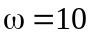
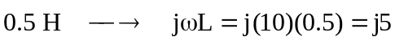
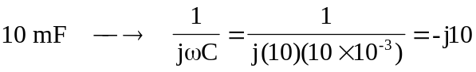

To find 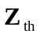, consider the circuit in Fig. (a).
(a)
1 A
10 W
2 V_{o}
-j10 W
V_{x}

+
V_{o}
-

j5 W

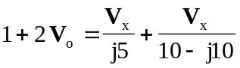, where 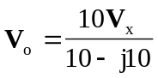
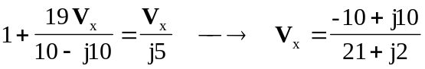

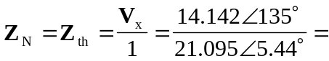 670Ð129.56° mW
2 V_{o}
10 W
j5 W
-j10 W
+
V_{o}
-

(b)
+
V_{th}
-
- +
-j2 A
12Ð0° V
I
To find 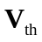 and 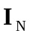, consider the circuit in Fig. (b).

where 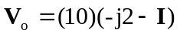

Thus,
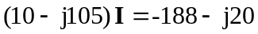
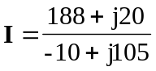

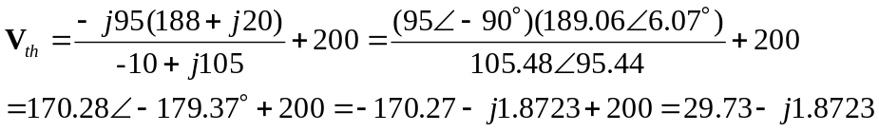

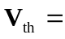 29.79Ð–3.6° V

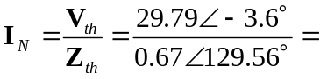 44.46Ð–133.16° A

